Detection Car Lens Zone

**Installation**

Github

1. Clone from this repo : <https://github.com/SuteeSaraphan/streamlit-yolov8.git>
2. Install python3 : <https://www.python.org/downloads/>
3. Install pip : <https://pip.pypa.io/en/stable/cli/pip_install/>
4. Use command to install library : pip install -r requirements.txt
5. If you want to use it with GPU install GPU Driver first (Recommend Nvidia GPU)
6. Run it with : streamlit run app.py

Docker

**How to use**

Go to <http://localhost:8501/>

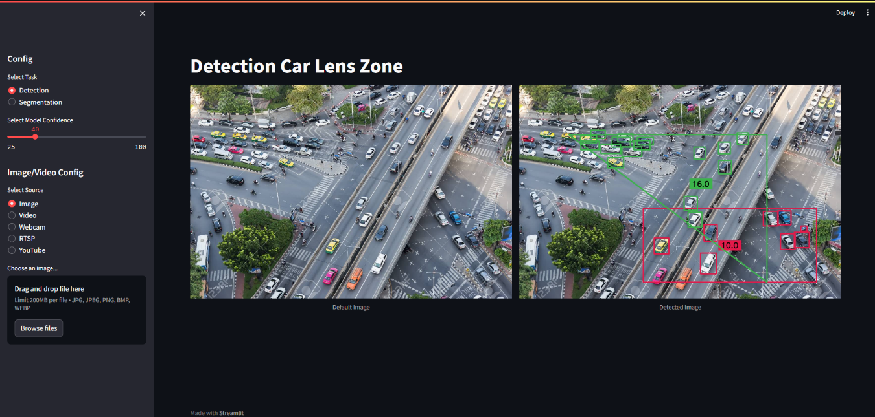

**Config**

Detection is refers to the task of identifying and locating specific objects (Default)

Segmentation it involves dividing an image into meaningful parts or segments and assigning a label to each segment

**Model Confidence** : refers to the level of certainty or trustworthiness associated with the predictions or decisions

Image/Video Config to select Source for detection

RTSP/Youtube

1. Put the link you want to detection first to url like : https://youtu.be/MNn9qKG2UFI?si=EYdlyW-j-KOQSDgH
2. Click load video to load for Draw a Zone of car you want to detection

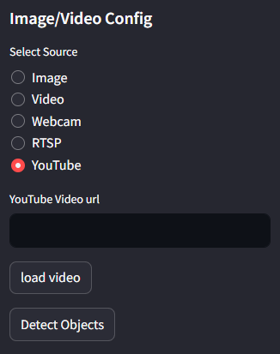

1. You can use Next Frame or Reset Frame to Display Frame that you want to Draw a polygon zone
2. You can Draw it with Left Click and drag line if it ok you can use Right Click to enter zone

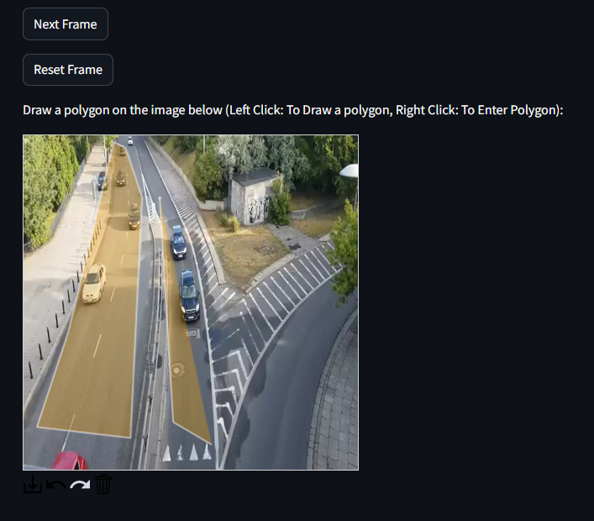

1. You can set the Mode for Interval, which will communicate the car's zone number in a JSON format to the URL you choose.
2. Interval time is a time that will send data/sec

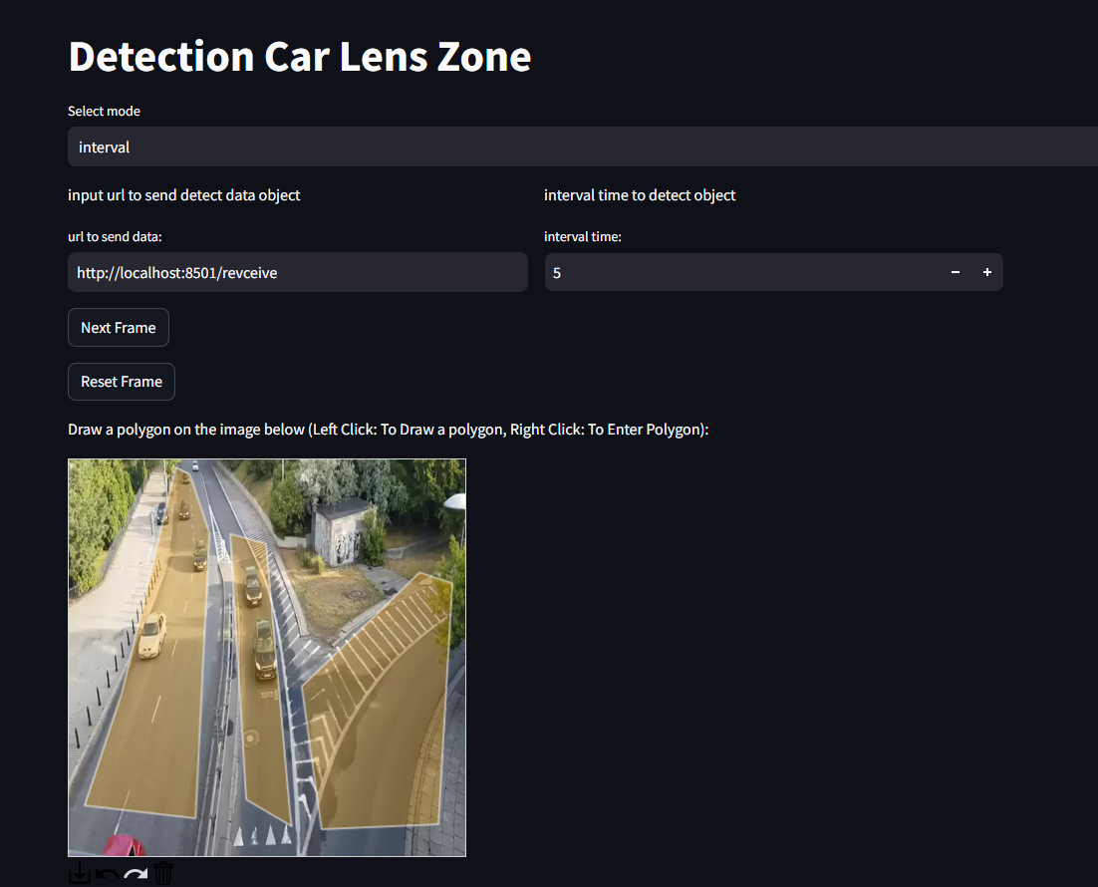

1. If the max_detect mode is used, json data will be sent if any zone is reached to the maximum; for instance, zone 1 is reached to 5. When a car is in a zone, it will send JSON data to a URL; if no zone is reached by 5 then there is nothing to send.

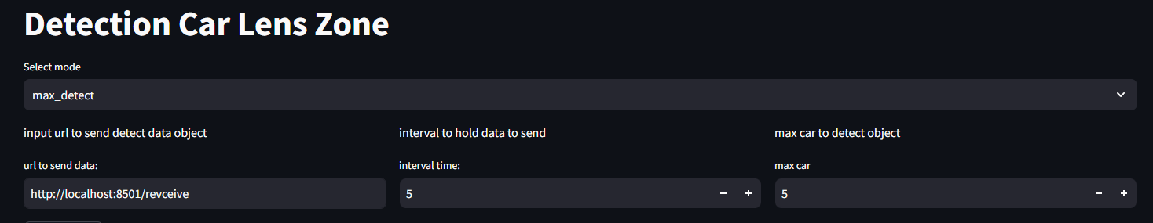

1. Detect Objects will detect and send json data from zone you draw and url you choose

